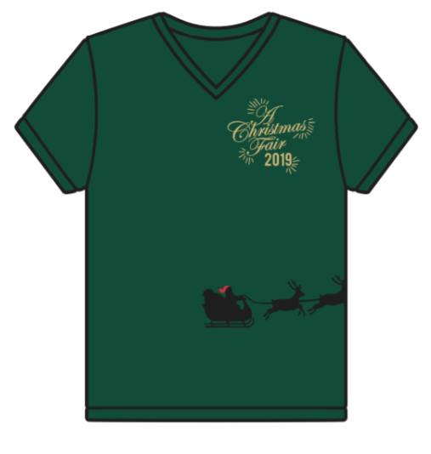

Christmas fair
t-shirt order form
Name:
Phone:
Email:

QUANTITY | STYLE | SIZE | COST PER SHIRT | SUBTOTAL
 | Women’s Short Sleeve |  | $21.00
 | Women’s Long Sleeve |  | $26.00
 | Youth Short Sleeve |  | $16.00
*Discount of $1 per shirt for purchases made by cash or check!
TOTAL:
Payment: Cash Check Credit/Debit Card (complete below)

Name on Card: Card Number:
Expiration: CVV: Billing Zip Code:

